**MAJOR PROJECT_______________**

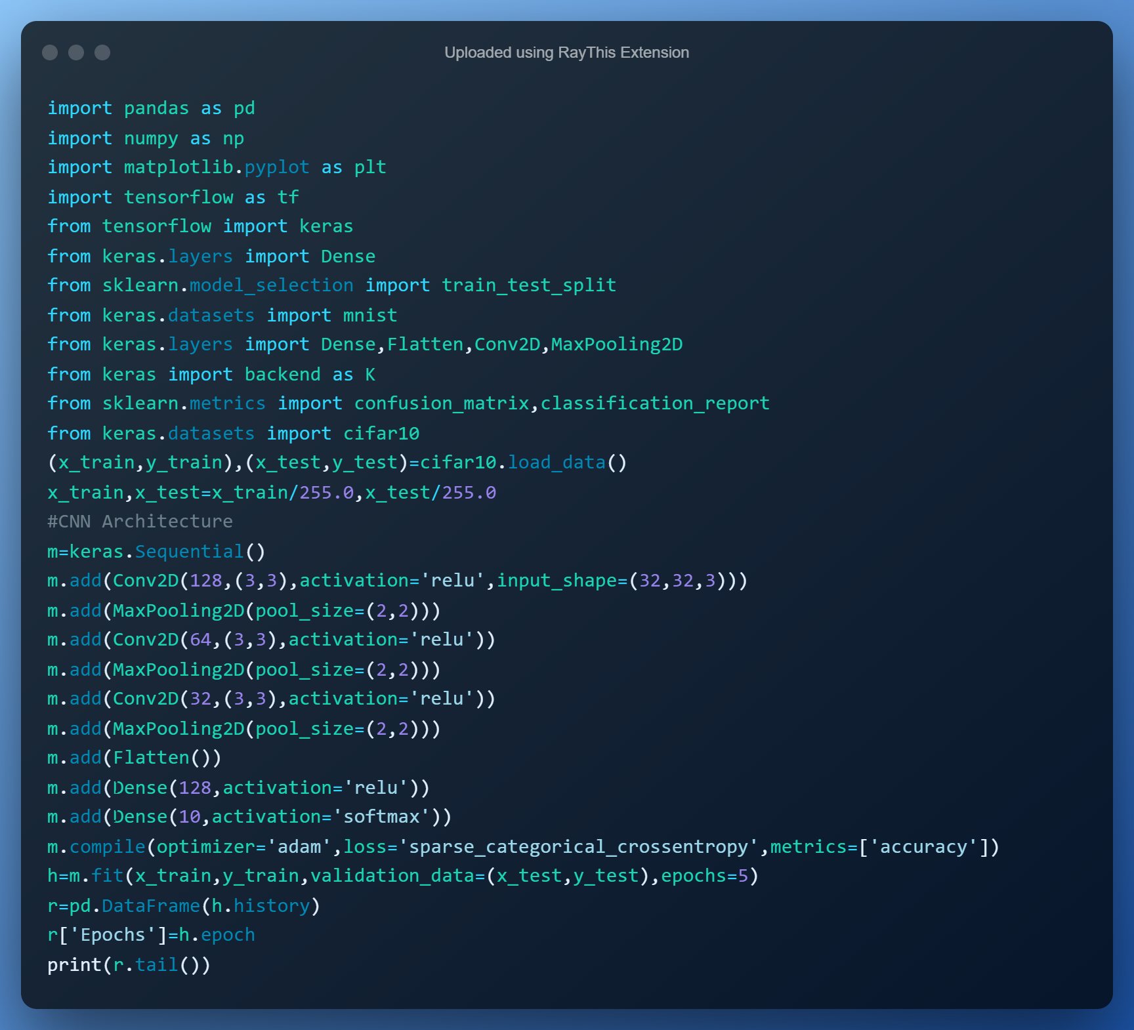

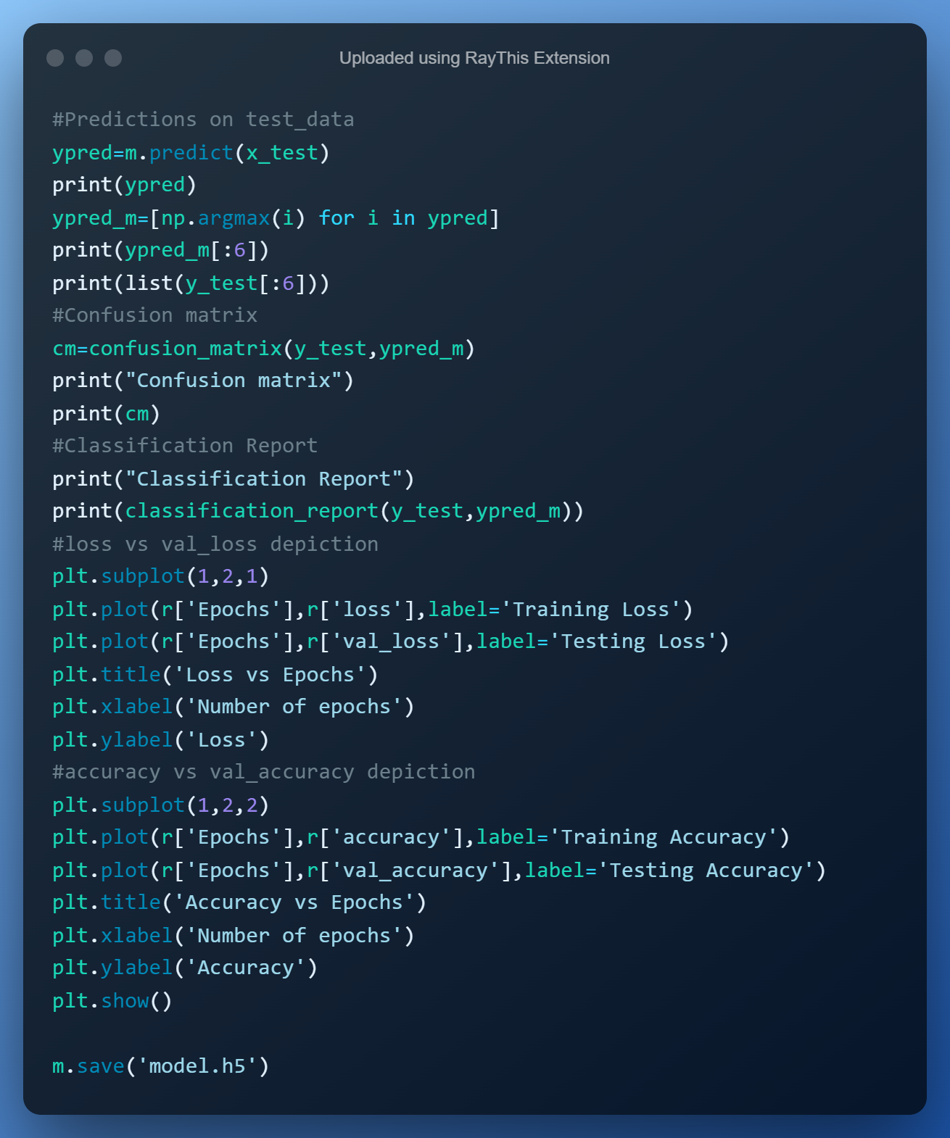

**OUTPUT:**

**Epoch 1/5**

**1563/1563 [==============================] - 104s 66ms/step - loss: 1.5966 - accuracy: 0.4120 - val_loss: 1.3273 - val_accuracy: 0.5145**

**Epoch 2/5**

**1563/1563 [==============================] - 96s 61ms/step - loss: 1.2648 - accuracy: 0.5469 - val_loss: 1.2076 - val_accuracy: 0.5707**

**Epoch 3/5**

**1563/1563 [==============================] - 115s 74ms/step - loss: 1.1348 - accuracy: 0.5944 - val_loss: 1.0821 - val_accuracy: 0.6196**

**Epoch 4/5**

**1563/1563 [==============================] - 93s 59ms/step - loss: 1.0518 - accuracy: 0.6291 - val_loss: 1.0410 - val_accuracy: 0.6381**

**Epoch 5/5**

**1563/1563 [==============================] - 100s 64ms/step - loss: 0.9820 - accuracy: 0.6532 - val_loss: 1.0506 - val_accuracy: 0.6271**

**loss accuracy val_loss val_accuracy Epochs**

**0 1.596573 0.41202 1.327287 0.5145 0**

**1 1.264839 0.54694 1.207603 0.5707 1**

**2 1.134773 0.59436 1.082141 0.6196 2**

**3 1.051840 0.62910 1.040994 0.6381 3**

**4 0.982037 0.65320 1.050571 0.6271 4**

**313/313 [==============================] - 9s 28ms/step**

**[[8.9757806e-03 5.8806757e-04 2.2065241e-02 ... 1.0430100e-02**

**6.1003242e-02 5.0793802e-03]**

**[5.3784645e-01 2.7463791e-01 2.0151321e-05 ... 1.6889172e-06**

**1.5704758e-01 3.0432964e-02]**

**[1.2514107e-01 3.8093129e-01 2.6029661e-02 ... 8.0325836e-03**

**1.2558369e-01 3.0091655e-01]**

**...**

**[5.0455837e-05 3.3450799e-06 5.6646932e-03 ... 1.3554710e-02**

**1.4171061e-05 1.9923067e-05]**

**[5.6844348e-01 1.2895343e-01 2.0028105e-02 ... 2.3326881e-02**

**5.5006804e-04 1.8971521e-02]**

**[1.3817852e-05 1.0575123e-05 4.1873199e-03 ... 8.7580067e-01**

**6.4636879e-07 2.4919725e-06]]**

**[3, 0, 1, 0, 6, 6]**

**[array([3], dtype=uint8), array([8], dtype=uint8), array([8], dtype=uint8), array([0], dtype=uint8), array([6], dtype=uint8), array([6], dtype=uint8)]**

**Confusion matrix**

**[[710 27 130 27 7 9 14 16 30 30]**

**[ 39 799 20 14 4 14 16 4 6 84]**

**[ 62 8 592 67 42 87 98 29 7 8]**

**[ 12 9 119 451 33 231 103 22 9 11]**

**[ 21 5 168 83 418 89 131 74 10 1]**

**[ 9 2 95 154 25 621 47 40 1 6]**

**[ 5 2 70 51 12 38 813 5 3 1]**

**[ 17 2 50 49 63 144 13 644 4 14]**

**[231 62 52 28 9 13 11 6 534 54]**

**[ 54 118 22 28 6 19 31 19 14 689]]**

**Classification Report**

**precision recall f1-score support**

**0 0.61 0.71 0.66 1000**

**1 0.77 0.80 0.79 1000**

**2 0.45 0.59 0.51 1000**

**3 0.47 0.45 0.46 1000**

**4 0.68 0.42 0.52 1000**

**5 0.49 0.62 0.55 1000**

**6 0.64 0.81 0.71 1000**

**7 0.75 0.64 0.69 1000**

**8 0.86 0.53 0.66 1000**

**9 0.77 0.69 0.73 1000**

**accuracy 0.63 10000**

**macro avg 0.65 0.63 0.63 10000**

**weighted avg 0.65 0.63 0.63 10000**

